1. 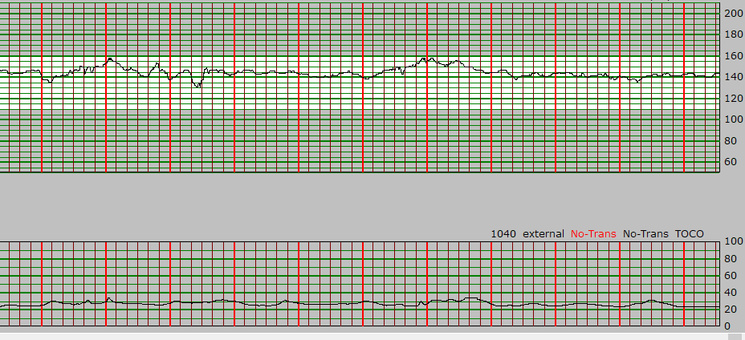Mrs. Nadine is a G4P0, at 28.2 weeks of pregnancy. She is admitted for PTL. Her membranes are intact and her cervix is soft and anterior, but closed. She is on the monitor for AM routine NST after a restless night and this is her tracing :

What is…

1. Your overall assessment? What would you ask Mrs. Nadine?

________________________________________________________________________________________________________________________________________________________________________________________________________________________________________________

1. The contraction pattern? How does it guide your assessment?

________________________________________________________________________________________________________________________________________________________________

________________________________________________________________________________

1. The FHR baseline?

___________________________________

1. The variability?

___________________________________

1. Are there any accels or decels?

___________________________________

1. Is the FHR normal?

___________________________________

You are unsure about the NST, what additional steps could you follow to insure that the NST is normal and reassuring?

____________________________________________________________________________________________________________________________________________________________________________________________________________________________________________________________

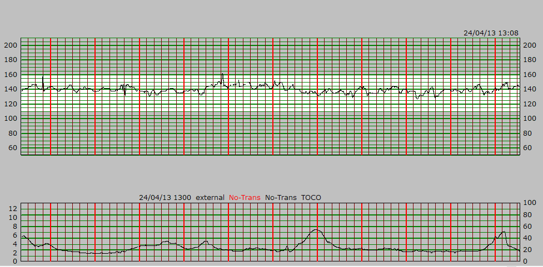Another nurse suggests that you review the patient’s previous NSTs to compare. Here is the NST of the day before:

What is…

* The contraction pattern?

________________________________________________________________________________

* The FHR baseline?

___________________________________

* The variability?

___________________________________

* Are there any accels or decels?

___________________________________

* Is the FHR normal?

___________________________________

* If you compare today’s NST and this one, what are the differences? How does this guide your assessment of today’s NST?

________________________________________________________________________________________________________________________________________________________________________________________________________________________________________________

1. a) Mrs. Claire is a G1P0 at 25wks of pregnancy with Di-Di Twins. She is admitted for short cervix. She is not known for contractions, PVB or PVL. She often complains that the babies move a lot. You attempt to do her routine doptone. How would you proceed?

____________________________________________________________________________________________________________________________________________________________

How would you describe the difference between a FH beat, the placental flow, and maternal pulse?

______________________________________________________________________________

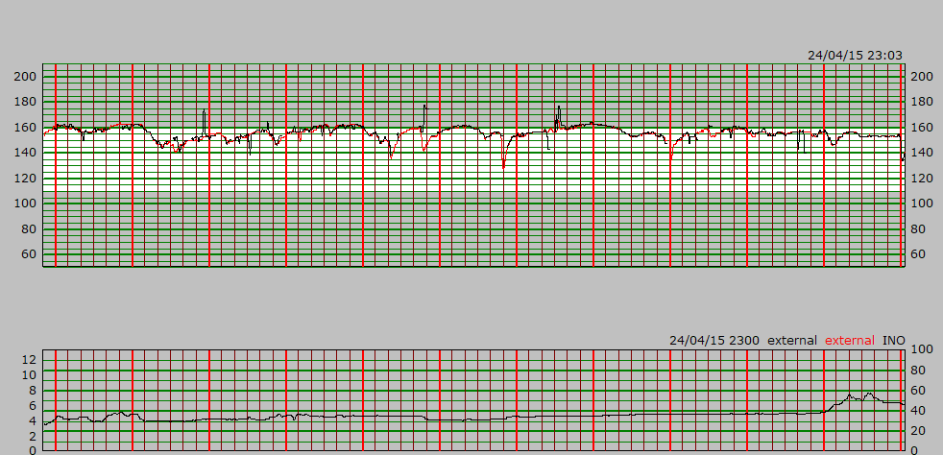b) Mrs. Claire is now 28wks and a NST is now required. Here is her tracing:

What is the FH baselines of BB1 and BB2?

__________________________________________________________________________

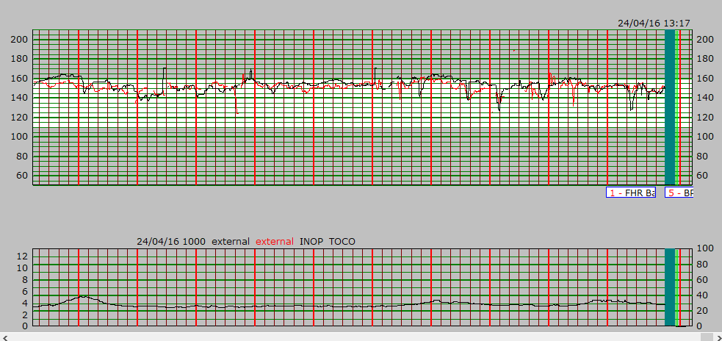c) Mrs. Claire turns on her side, and this is now her tracing:

How would you analyze this tracing (Both FHR and Ctx)?

____________________________________________________________________________________________________________________________________________________________________________________________________________________________________________________________________________________________________________________________________________________

How can you make sure you are tracing both babies separately?

_______________________________________________________________________________________________________________________________________________________________________________________________________________________________________________________________

1. Mrs. Bianca is a G1P0 at 24.4wks at pregnancy. She was admitted yesterday for PPROM. During your round, as you put her on the monitor, you ask her if she has any Ctx, PVB or PVL. She answers no, but states “I just feel really tight, like I ate too much”.

* Where would you place your monitors

(FH and Toco)?

* How likely is Mrs. Bianca to deliver today? This week?

_________________________________________

_________________________________________

* Considering your assessment, how often would you assess Mrs. Bianca today?

_____________________________________________

1. 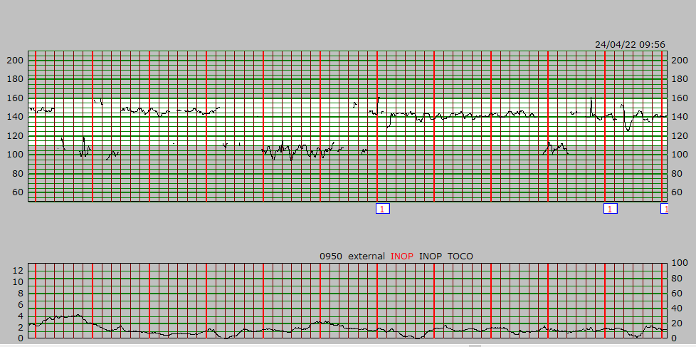Mrs. Jennifer is G2P1 at 30 weeks of pregnancy, she is admitted for observation for bleeding. She is known placenta previa. This is her tracing.
2. How would you analyze this tracing (FHR and Ctx)?

__________________________________________________________________________________________________________________________________________________________________________________________________________________________________________

1. Seeing this tracing, what intervention would you do?

______________________________________________________________________________

1. What is the difference between a placenta previa and a vasa previa?

____________________________________________________________________________________________________________________________________________________________

Later, Mrs. Jennifer rings her call bell and reports that she had an episode of large amount of PVB with clots while in the bathroom. She is also reporting some mild cramps.

1. What is your first intervention?

______________________________________________________________________________

1. What would you do next?

________________________________________________________________________________________________________________________________________________________________________________________________________________________________________________________________________________________________________________________

1. You are calling the MFM resident, what information would you give him?

______________________________________________________________________________________________________________________________________________________________________________________________________________________________________________________________________________________________________________________________________________________________________________________________________

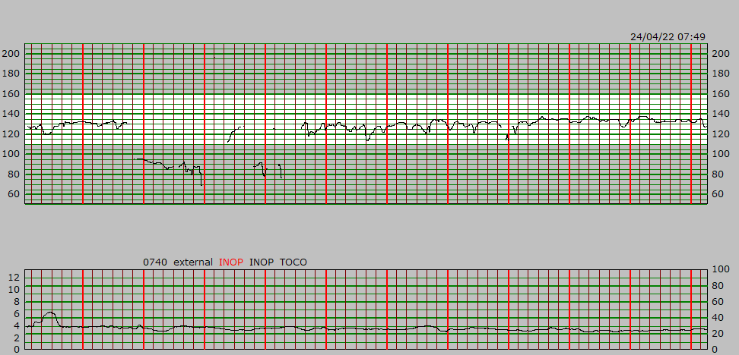This is the tracing of Mrs. Jennifer after the bleed.

1. How would you analyze this tracing?

__________________________________________________________________________________________________________________________________________________________________________________________________________________________________________

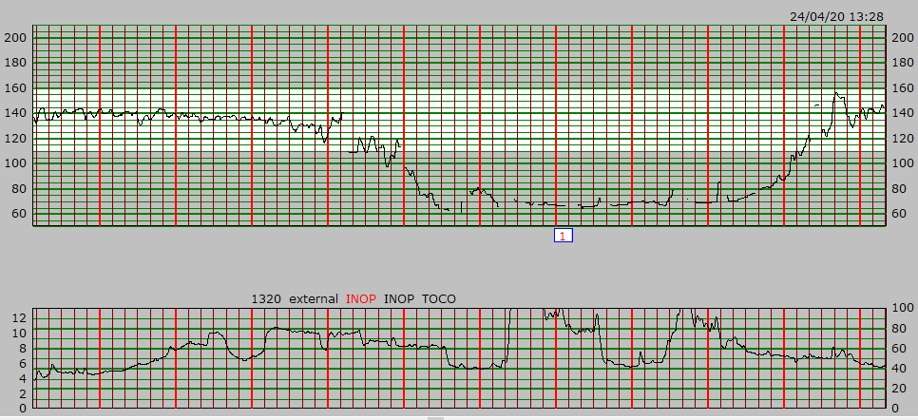You keep Mrs. Jennifer on the monitor longer and this is her tracing:

1. How would you analyze this tracing?

__________________________________________________________________________________________________________________________________________________________________________________________________________________________________________

1. Since you already did the interventions identified in e) and f), what else can you do?

____________________________________________________________________________________________________________________________________________________________

______________________________________________________________________________

1. 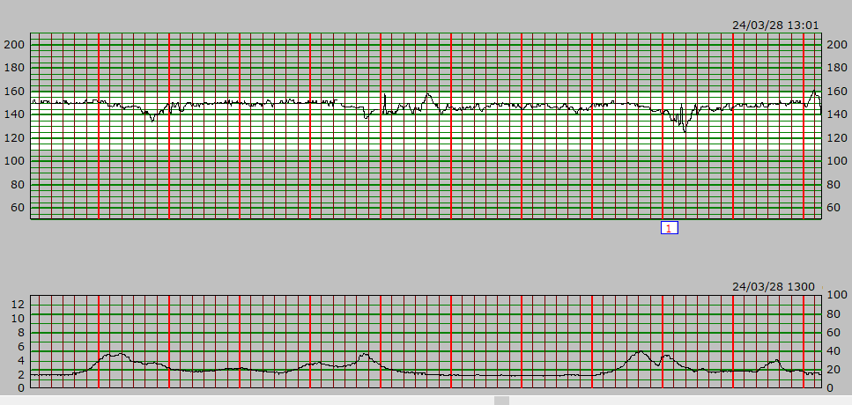Mme. Ruby is a G1P0 at 36.4 wks of pregnancy. She is an IOL for PET. Her BP is well controlled but her labs are worsening. She is known for velamentous cord insertion. She has received 3 doses of cytotec already and you are making your assessment for a 4th dose. This is her tracing:
2. How would you analyze this tracing (FHR and Ctx)?

__________________________________________________________________________________________________________________________________________________________________________________________________________________________________________

1. What would be your first intervention and why?

__________________________________________________________________________________________________________________________________________________________________________________________________________________________________________

1. After having done what you identified in b), if there is no improvement, what are your next steps?

__________________________________________________________________________________________________________________________________________________________________________________________________________________________________________

1. You are calling the junior resident, what information would you give him?

______________________________________________________________________________________________________________________________________________________________________________________________________________________________________________________________________________________________________________________________________________________________________________________________________

1. What is a velamentous cord insertion and what does it mean for IOL management?

______________________________________________________________________________

1. Mrs. Gladys is G2P0 at 39.4wks of pregnancy and admitted for induction on labor for GDMA1 with cytotec. Her 4th dose was given 3 hours ago. She called you and says she is feeling a lot of contractions.
   1. What is your first intervention?

______________________________________________________________________

* 1. How would you analyze this tracing (FHR and Ctx)?

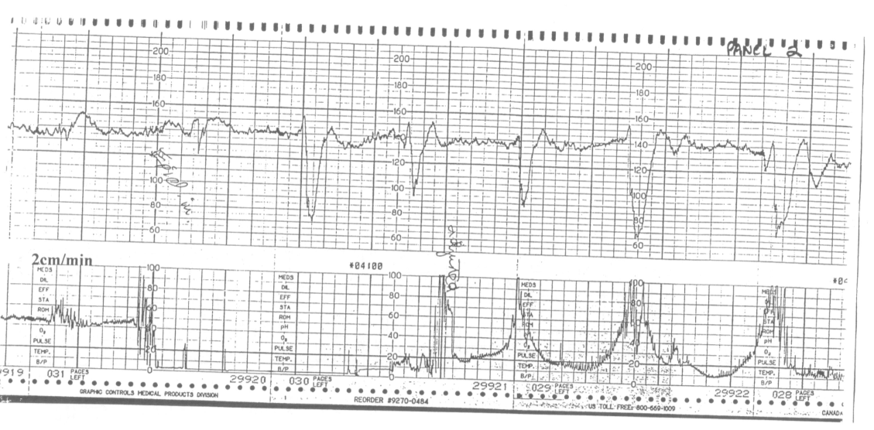_________________________________________________________________________________________________________________________________________________________________________________________________________________________________

* 1. The resident is busy in the BC for a delivery. What can you do in the meantime and why? ________________________________________________________________________________________________________________________________________________________________________________________________________________________________________________________________________________________________
  2. You call the resident, what information do you give her?

________________________________________________________________________________________________________________________________________________________________________________________________________________________

* 1. You transfer Mrs. Gladys to the BC, what information would you give to the nurse?

________________________________________________________________________________________________________________________________________________________________________________________________________________________

1. 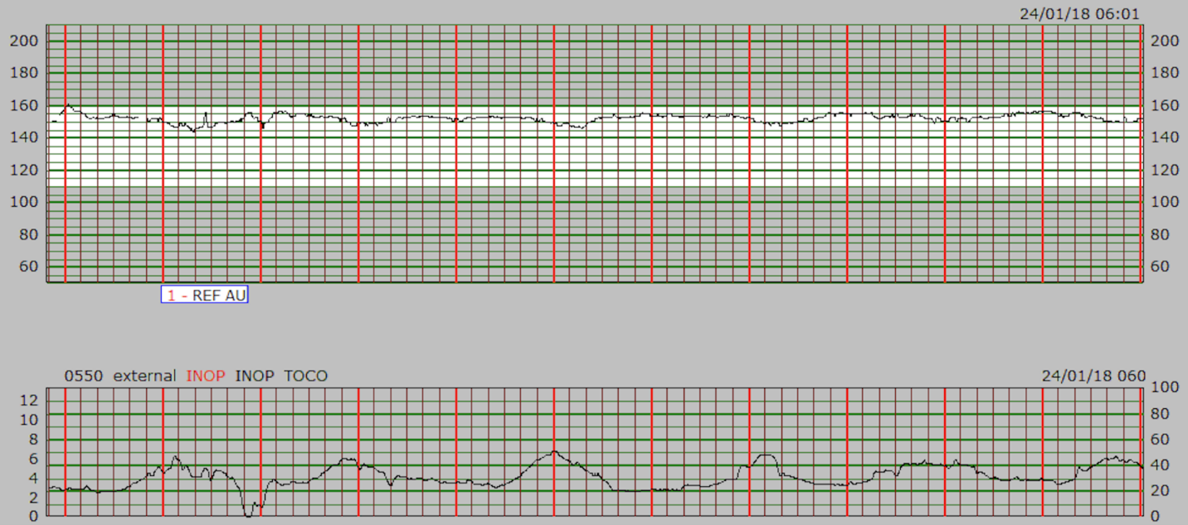Mrs. Laura is a G4P0 at 27.3 wks of pregnancy. She is admitted for IUGR with AEDF. You put her on the monitor for her routine NST. This is her tracing :
2. How would you analyze her tracing?

__________________________________________________________________________________________________________________________________________________________________________________________________________________________________________

1. How would you intervene?

______________________________________________________________________________

______________________________________________________________________________

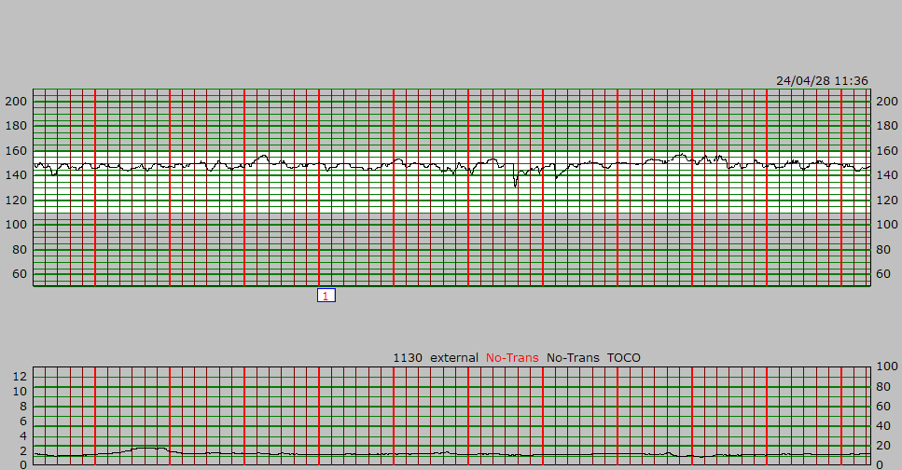Mrs. Laura goes to the BC for continuous monitoring. The next day, you see that she is still pregnant. You look at her tracing :

1. How would you analyze this tracing?

____________________________________________________________________________________________________________________________________________________________You are reassured to see that her tracing has improved. However, you notice that on the BC chalkboard that she is scheduled for a C/S and that it says “REDF with Redistribution”.

1. What is redistribution and how does it impact the FHR and the management of the patient?

__________________________________________________________________________________________________________________________________________________________________________________________________________________________________________