CORE VALUES NOMINATION FORM

Please scan the QR code below to access the nomination form for our four core values:
Collaboration – Teamwork – Empathy – Professionalism

We encourage all staff members to highlight colleagues who demonstrated these values in their daily
practice. Thank you for contributing to a positive and supportive work environment.

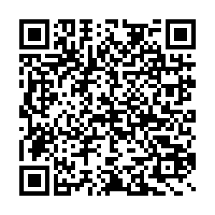

Thank you for your participation!

