Memos of the week October 20th 2025

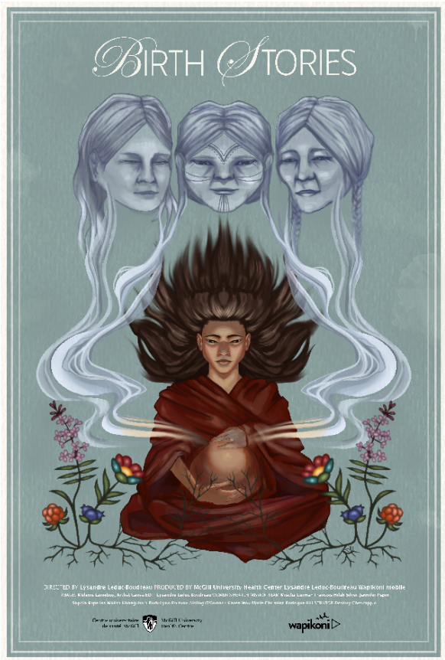

Lancement de BIRTH STORIES Launch – October 29th
All our team members are invited to attend the launch of the video/movie Birth Stories, where 5 Indigenous women share their stories of birth. The initial goal of the video was to use storytelling to teach staff about the reality of Indigenous women having to leave their families and communities to give birth with us. The storytellers have agreed to have the launch go public and more than 170 people have registered to attend the virtual launch from all over Quebec and Canada!
BUT! Because this was done primarily for our team, we would love for you to be present LIVE at the GLEN amphitheatre on October 29th, from 10am-12pm. There will be some food too!
If you are interested in being present in person, PLEASE EMAIL SOPHIA at Sophia.kapellas@muhc.ca
If you can’t be there in person but wish to attend online, register here:
Lancement de la vidéo « Birth stories » - Launch of the video “Birth Stories” | Meeting-Join | Microsoft Teams
Nursing Newsletter October 2025
The October edition is out! Please See attachment.

Planned Downtime e-TraceLine
Please be advised that on Thursday, October 30, 2025 from 11:00 am to 12:00 pm, the e-TraceLine system will be unavailable. See attachment for details.

Cord blood collection for Lupus Patient
Please be aware that there will now be 2 tubes of cord blood collected at the time of birth. This includes the usual Red/Grey topped tube (serum) as well as a new Pale Blue tube (plasma). Message from Heart of the Matter(HOM).

OACIS application Maintenance
A new version of OACIS will be deployed on Tuesday, October 28, 2025. As a result, the OACIS application will be unavailable on October 28 from 10:00 PM to midnight due to scheduled maintenance.
If you have any computer-related issues, please contact the Service Desk at extension 48484 for assistance.

Trash to Treasure: Pop-up days
See attachment for details.

POCT Recertification
Please note that the deadline for the annual Glucometer recertification is November 14th.

CHRISTMAS PARTY
The sign-in sheets are up in the lounge. RSVP BY November 18th.
Please see the attached poster for more details.

Have a great week everyone!
Ingrid, Malisa, Akari, Mirvat, Ruth-Lynn, Elisabeth, Magda & Sophia

Attached documents:
- Downtime traceline
- Nursing newsletter October 2025
- Trash to treasure pop-up
- Poster for Christmas party

